**Following source ids having same structure**

|  |  |
| --- | --- |
| SOURCE ID | BASED URL |
| 77639799 | https://www.jstage.jst.go.jp/browse/jilm/list/-char/en |
| 77652699 | https://www.jstage.jst.go.jp/browse/rtriqr/list/-char/en |
| 77658199 | https://www.jstage.jst.go.jp/browse/tjsass/list/-char/en |
| 77660699 | https://www.jstage.jst.go.jp/browse/qjjws/list/-char/en |
| 77660799 | https://www.jstage.jst.go.jp/browse/yukigoseikyokaishi/list/-char/en |
| 77660899 | https://www.jstage.jst.go.jp/browse/jcorr/list/-char/en |
| 77660999 | https://www.jstage.jst.go.jp/browse/jsms/list/-char/en |
| 77666699 | https://www.jstage.jst.go.jp/browse/itej/list/-char/en |
| 77728399 | https://www.jstage.jst.go.jp/browse/jjlp/list/-char/en |
| 77730499 | https://www.jstage.jst.go.jp/browse/electrochemistry/89/Announcements/_contents/-char/en |
| 77902199 | https://www.jstage.jst.go.jp/browse/matertrans/list/-char/en |

Go to the based url so the landing page will be appear like below

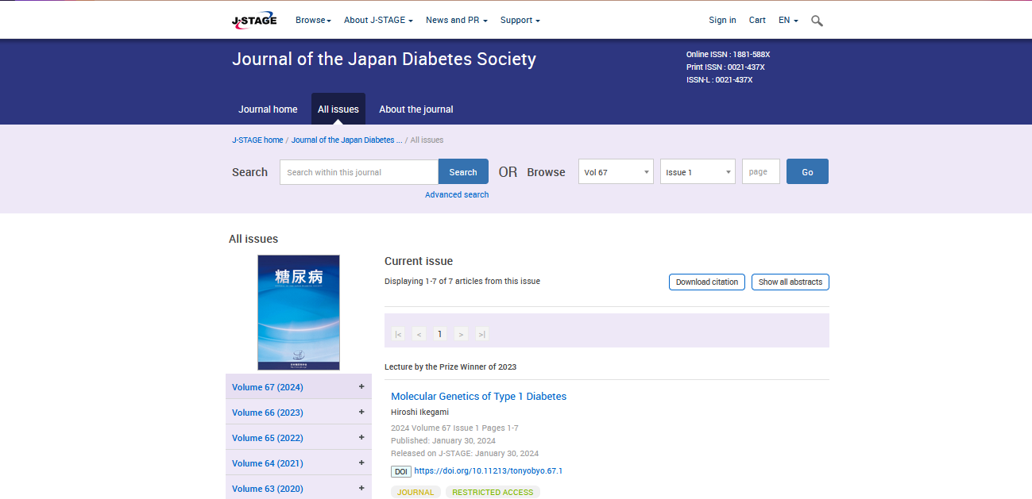

**Select the Current issue from here.**

* **All required articles will be listed here.**

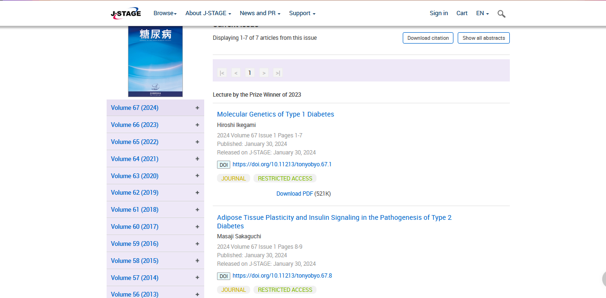

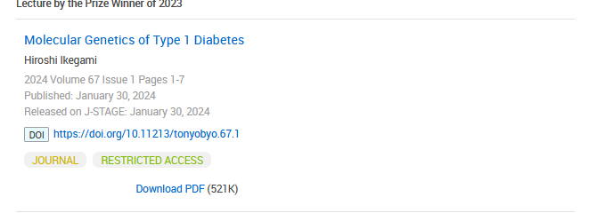**Meta data can be captured as below.**

**Volume, issue and Year, PAGE RANGE**

* **Click the article name to open the article information page to download the PDF.**

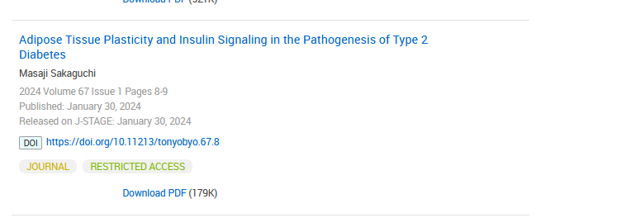

**Article name**

**DOI (start with 10)**

**Click the download link to download the PDF.**

**Page Range**